**DAA ASSIGNMENT 3**

OUTPUT FOR THE CSV FILE OF 2000 EMPLOYEES:

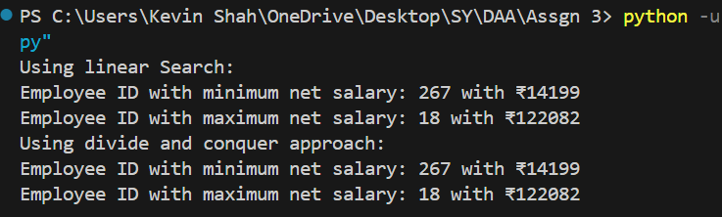

Test Case 1 (Invalid):

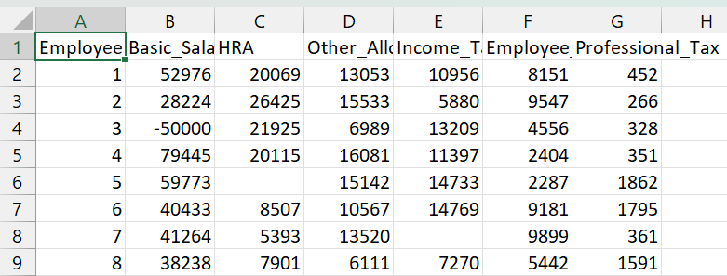

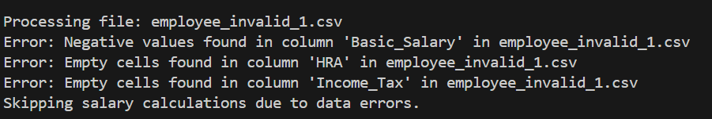

Test Case 2(Invalid):

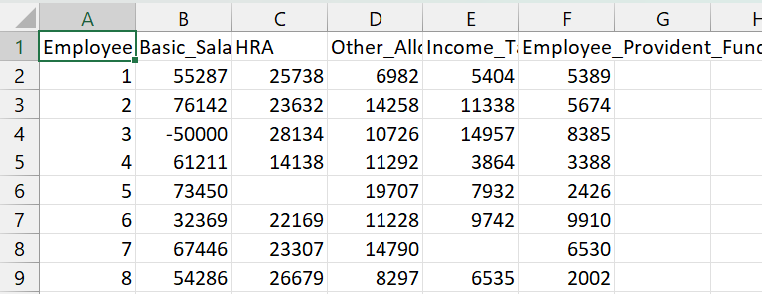

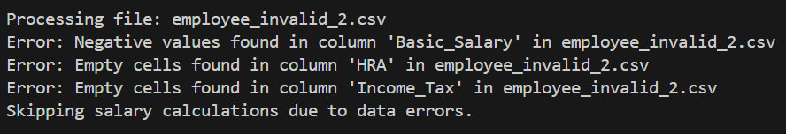

Test Case 3(Invalid):

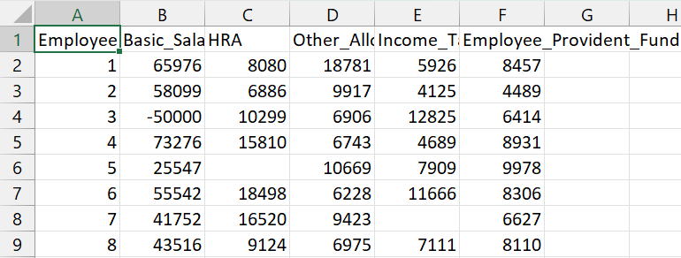

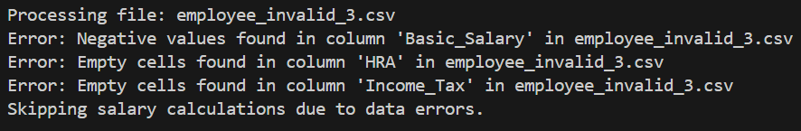

Test Case 4(Invalid):

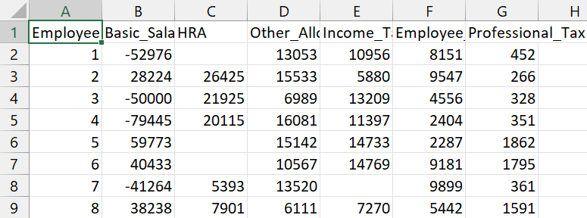

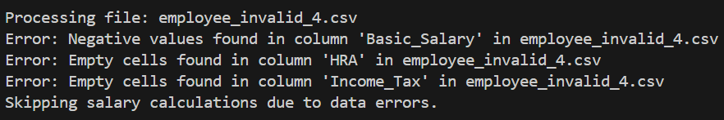

Test Case 5(Invalid):

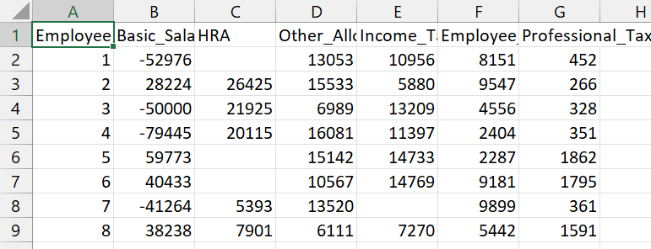

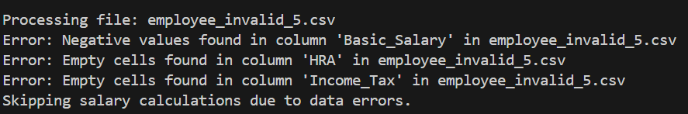

Test Case 6(Valid):

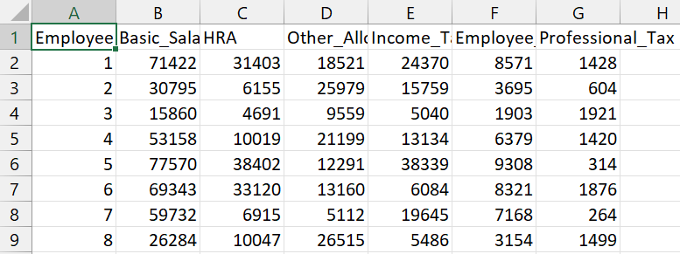

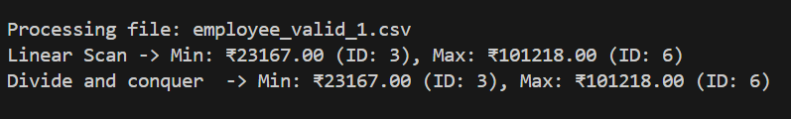

Test Case 7(Valid):

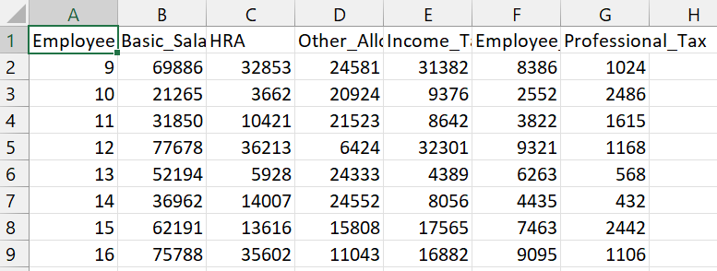

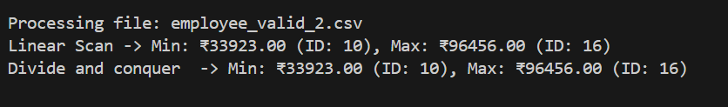

Test Case 8(Valid):

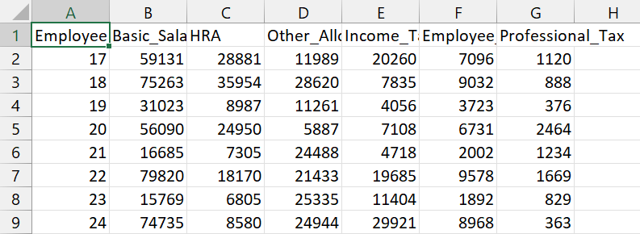

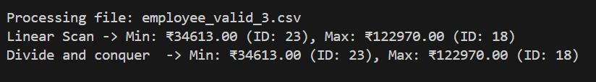

Test Case 9(Valid):

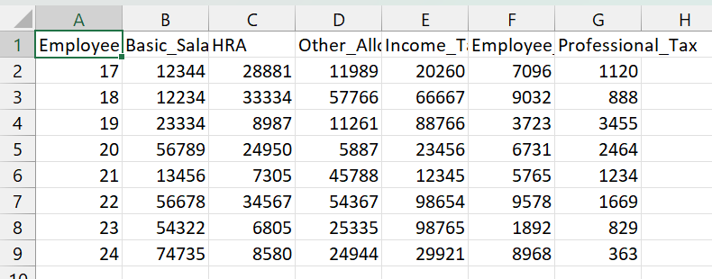

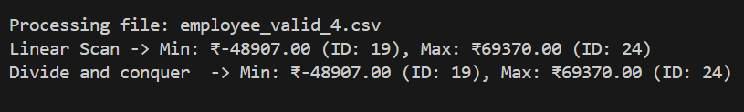

Test Case 10(Valid):

